<Warrior: Nobody>



Z5125807 Chenming Fan

Z5135119 Jiacheng Yang

Z5138091 Li Ding

Z5125854 Xiangzhi Zhang

Z5125612 Wenbo You

# 

# 

# Overview

## **Theme**

* + 2D Top-Down Roguelike Game

## **Core Gameplay Mechanics Brief**

* + Player using different type of weapon to pass dungeon
  + Get coin from enemies
  + Buy new weapon from shop

## **Targeted platforms**

* + Windows

## 

## **Project Description**

“WARRIORS: NOBODY”is a 2D Top-Down Roguelike game which is based on the dungeon theme. Our team get the inspiration from both Roguelike game and RPG game, trying to combine the core mechanics of these two types of games together. According to our observation, there are plenty of 2D shooting games in the market but the main problems are that the variety of weapons is not sufficient enough and the game levels are not designed properly, either too easy or too difficult. Therefore, we abandon the traditional level mode and move the key points of the game to focus on the weapon system. Through the rich weapon system, we are motivated to let players obtain the most exciting and interesting experience from one single quick game rather than wasting time on making a breakthrough. Our target customers are gamers, especially for those who love the 2d shooting games.

## **Core Gameplay Mechanics**

* + Player movement
    - Player can move toward 8 direction. They can not through any wall and box.
  + Weapon system
    - Player can shoot enemies by right click
    - Shooting direction is according to mouse direction.
    - Player can switch weapon by click 1 2 3 4 or using mouse wheel
    - Player can buy weapon from shop
    - Weapon has different damage and different attack speed
  + Dungeon
    - Our game has 4 dungeon level1 level2 level3 and boss room
    - Player can enter next level, only when the last level finished.

* + Item drop
    - When enemies death, it will drop a few coins and some potions
    - How many coins they drop is randomly

# Gameplay

## **Character**

* +  basic character in game
  +  unlock in shop
  + unlock in shop
  +  unlock in shop

## **Enemies**

* +  remote attack
  + 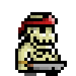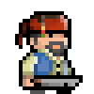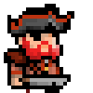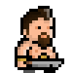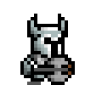 short distance attack
  +  can not move but with high and remote attack speed
  + Boss have two stages with different attack mode

## **Map**

* + Level 1
  + 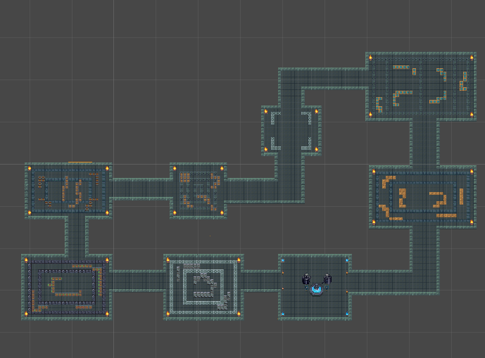
  + Level 2
  + 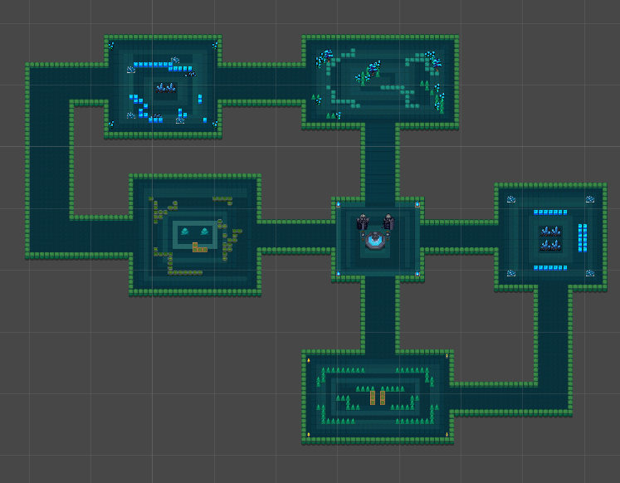
  + Level 3
  + 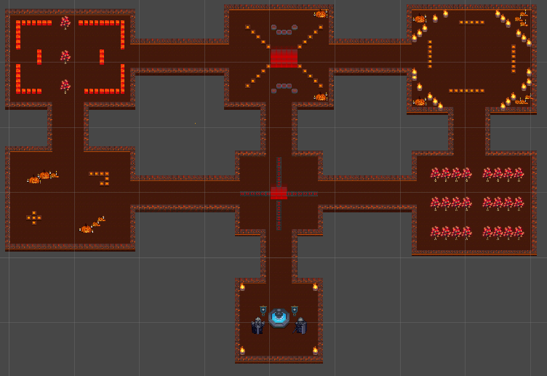
  + Boss room
  + 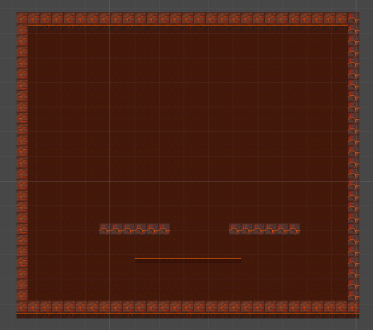

## **Weapon**

* + long range remote weapon
  + short range weapon

## **Shop**

* 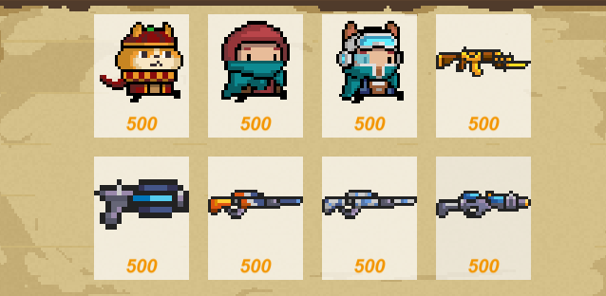

# Assets

## **2D image and Sound**

* + All assets from unity assets store, opengameart , and others website

## **Code**

* + All scripts are c#
  + Character Scripts
    - Write in PlayerControl.cs
  + Enemies Scripts
    - Write in enemyControl.cs and BossControl.cs
  + Save and load Scripts
    - Write in SaveSystem.cs and PlayerDate
  + Weapon Scripts
    - Write in WeaponControl.cs and bulletEffect
  + Character Scripts
    - Write in PlayerControl.cs
  + Other scripts are control the ui and store some data

## **Animation**

We use animator to create the animations of characters and enemies

* + Character Animations
    - Player
      * Idea
      * move 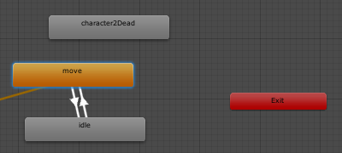
    - Enemies
      * Idea
      * Move
      * Dead 